**HTML Element**

**Table of content**

* What is HTML Element Definition?
* What is element in HTML with example?
* What is the Difference between HTML tag vs HTML Element?
* What is the purpose of HTML elements?
* What are the basic elements in HTML?
* What is Nesting concept in HTML?

**What is HTML Element Definition?**

HTML Element is defined as the content which is use or written in between Start tag and End tag. It is a concept of providing special text, standard content, special attributes within the start tag and end tag. The content may be use for formatting your HTML web page. Example – For Providing hyperlink and image to the content, for making your text bold, For Providing special Heading to your document, For Inserting table into your web page etc.

**What is element in HTML with example?**

HTML element define only the text written inside start and end tag. All HTML tag contain HTML element even overall HTML code itself is an example of HTML element. If HTML code starts with <html> and end with </html> then the overall content within two tags is also considered as HTML element.

**Example of HTML elements-**

<tag name> Text written here is considered as HTML content </tag name>

**<h1> This is my HTML Heading </h1>**

In the above example the text which is written within the start <h1> tag and end</h1> tag is considered as HTML element. The example of Heading tag and how your HTML content will display on the browser is explain below.

**Example-**

<!DOCTYPE html>

<html>

<head>

<title>heading</title>

</head>

<body>

<h1> Here is my Main heading </h1>

<h2> heading 2</h2>

<h3> heading 3</h3>

<h4> heading 4</h4>

<h5> heading 5</h5>

<h6> small heading 6</h6>

</body>

</html>

**Output** –

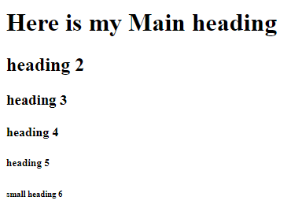

**<p> This is an example of paragraph tag. If you want to write a paragraph in your html document then paragraph tag is used </p>**

Similarly, In the paragraph tag also the content within the <p> tag and </p> represent HTML element in HTML document.

**Example-**

<!DOCTYPE html>

<html>

<head>

<title>Paragraph tag</title>

</head>

<body>

<p> This is an example of paragraph tag. If you want to write a paragraph in your html document then paragraph tag is used </p>

</body>

</html>

**Output –**

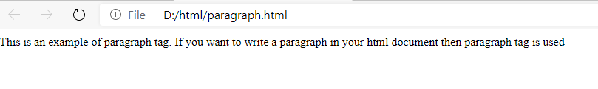

**<p style="color:red;">My paragraph is in red colour</p>**

In the above example,

* **<p -** shows start tag
* **Style -** shows HTML attribute
* **color:red -** shows Value
* **My paragraph is in red colour -** shows HTML content
* **</p>-** shows end tag

**The Basic HTML Elements of an html Page are given below –**

|  |  |  |
| --- | --- | --- |
| **<start tag>** | **HTML Elements** | **<end tag>** |
| <h1> | This is my HTML Heading | </h1> |
| <p> | This is my HTML Paragraph | </p> |
| <a href="#"> | click here to go on link | </a> |
| <span style=” color:red ”> | Red | </span> |
| <font size="6"> | Text size will be 6 | </font> |
| <br> | None | None |

**NOTE –** In HTML, some HTML elements does not have content. Ex - <br> tag. Such type of elements known as empty elements. Empty elements do not have end tag.

Similarly, In HR tag where HR represents (horizontal rule) tag. <hr> tag use in between the paragraph tag for providing line spacing between the paragraph. <hr> tag does not have end tag.

**What is the Difference between HTML tag vs HTML Element?**

Html Element and HTML tag both are written simultaneously within the HTML code but both HTML tag and HTML element has different meaning.

HTML tag represents main part of your HTML element where its start tag starts with open angle bracket “<” end ends with close angle bracket “>”. Similarly, with end tag its start tag starts with open angle bracket “<” end ends with close angle bracket “>” and back slash inside it. **Example –**

**<start tag> content </end tag>**

HTML element can be the attribute, value, content everything written inside the start and end tag. HTML element starts with the HTML start tag and end with the HTML end tag.

**Example –**

**<h1> Whatever the content you write here will be considered as HTML element <h1>**

Above example is an example of heading tag where the text written inside <h1> and <h1> will be considered as HTML element.

**What is the purpose of HTML elements?**

In HTML It is very important to understand HTML Element and what exactly the purpose of HTML element. The overall text within the HTML document which is written under start tag and end tag will be responsible for output which will represent your website. Whatever the content or any changes made by the user will directly displayed on the website or webpage.

The main content withing the text file which may contain so important instructions, special attributes which may help your website to look attractive.

**What are the basic elements in HTML?**

Basic elements in HTML consists of-

* Heading tag represents the heading in HTML document as an HTML element. Heading tag consists of six tags which are H1, H2, H3, H4, H5 and H6. <h1> </h1> Represents most important and main heading and <h6></h6> Represents small heading and least important heading.
* Paragraph tag means <p> tag in HTML document shows paragraph in HTML element.
* The content within the Horizontal rule <hr> tag also represents basic HTML element. Horizontal rule in html is use in paragraph, if user wish to add some line spacing between the paragraph like shift spacing or thematic break then the concept of horizontal rule is used.
* The content within ul means unordered list considered as HTML element for defining unordered list in HTML document.
* The content within ol means ordered list considered as HTML element for defining ordered list in HTML document.
* Image tag <img> consist of attribute, value as well as content which is to be considered as HTML element.
* Anchor tag <a> also consist of attribute, value as well as content which is to be considered as HTML element.

**What is Nesting concept in HTML?**

Nested HTML elements means one HTML element may contain other elements. In HTML, All the html code itself is an example of nested HTML elements.

**Example -**

<!DOCTYPE html>

<html>

<head>

<title> heading </title>

</head>

<body>

<h1> Here is my Main heading </h1>

<p> This is my HTML Paragraph </p>

</body>

</html>

**Output-**

